**Английский язык**

**8-9 класс**

**Рабочий лист** (обучающийся) **-2-й этаж**

**«Время первых»**

**English for 8–9th grades**

**The -2nd floor**

**“Time of the First”**

**Installation “Towards the Dream”**

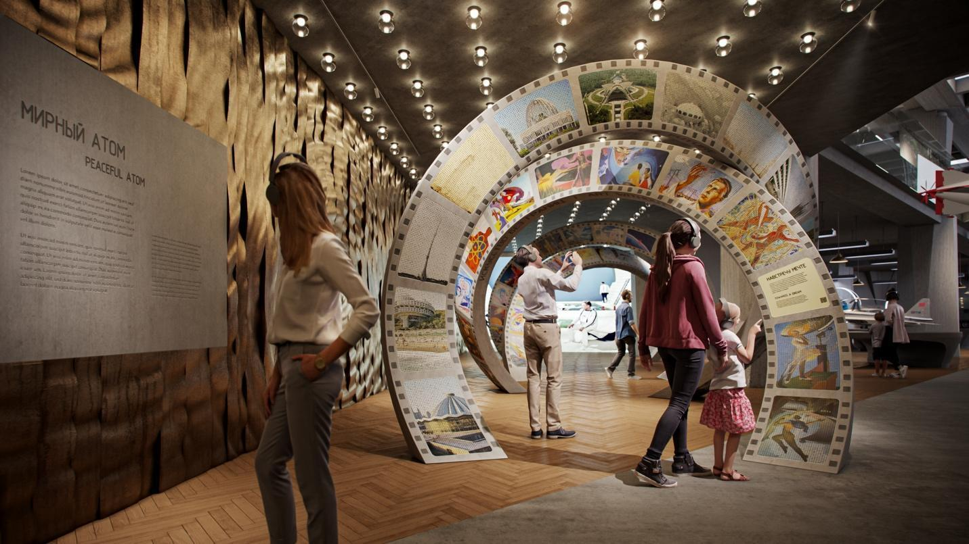

The middle of the twentieth century. The Soviet people are mastering nuclear energy, launching a satellite and are about to send the first man into space. A new era that should change life radically is beginning. What will this new life look like? People of various professions are looking for answers to this question. Scientists make calculations and put forward technical innovations. Artists and architects are abandoning the old forms. Writers and directors guess in novels and films what a new world will look like. Fascinated by fantastic forecasts, people leave messages to their descendants in special capsules. The whole country is rushing into the future.

**Task 1.** **Connect the beginning and the end of the sentences so that you get a coherent text.**

|  |  |  |  |
| --- | --- | --- | --- |
| **1.** | The era of the 1950s and 1960s | **A** | a great boost for creativity — both for physicists and lyricists. |
| **2.** | This is a time when science goes far beyond laboratories and | **B** | becomes a time of scientific and technological revolution all over the word. |
| **3.** | Human flight into space and the conquest of atomic energy provide | **C** | he conveys his impressions of observing the planet from a spacecraft. |
| **4.** | Cosmonaut Alexey Leonov paints the picture “Morning in Space”, in which | **D** | inspires artists and architects, writers and poets. |

**Answer:**

|  |  |  |  |
| --- | --- | --- | --- |
| **1.** | **2.** | **3.** | **4.** |
|  |  |  |  |

**2. Look at the pictures and match them with the corresponding titles.**

1. The City of the Future. G. Pokrovsky
2. Morning in Space. A. Leonov
3. Earth and Time: Youth. K. Mullashev
4. The Conquerors of Space. A. Deineka

|  |  |  |  |
| --- | --- | --- | --- |
| **А**  **В Роскосмосе рассказали о преимуществах запуска с космодрома «Восточный» |  ИА Красная Весна** | **B** | **C**  **№13.143 Муллашев Камиль... - Искусство СССР / Soviet art | Facebook** | **D**  **Картины советского космонавта Алексея Леонова — Сноб** |

**Answer:**

|  |  |  |  |
| --- | --- | --- | --- |
| **1.** | **2.** | **3.** | **4.** |
|  |  |  |  |

**2.1. The text panel “Peaceful Atom”**

**3.** **Choose the most appropriate meaning of the word “peaceful” in the word combination “peaceful atom”.**

a) Not inclined to hostility, quarrels. Filled with friendly agreement.

b) Not military. Based on the observance of peace.

c) Related to the resolution of a dispute, litigation without trial, peacefully.

d) Alien to unrest, calm, quiet.

***Answer:*** _________

**The media program “The Soviet Films about the Future”**

The media program “The Soviet Films about the Future” complements the content of the section “Peaceful Atom”. The selected episodes of the films convey the images of the future that the Soviet society lived in the 1950s – 1980s. They illustrate the hopes for scientific and technical discoveries that became possible thanks to the key breakthroughs of the twentieth century — the development of atomic energy and the conquest of outer space.

**4. Which film title in the original language sounds like “Per aspera ad astra”?**

a) Andromeda Nebula

b) Moon Rainbow

c) Through the Thorns to the Stars

d) The Orion Loop

***Answer: _________________________***

**The exhibition area “Submarines”**

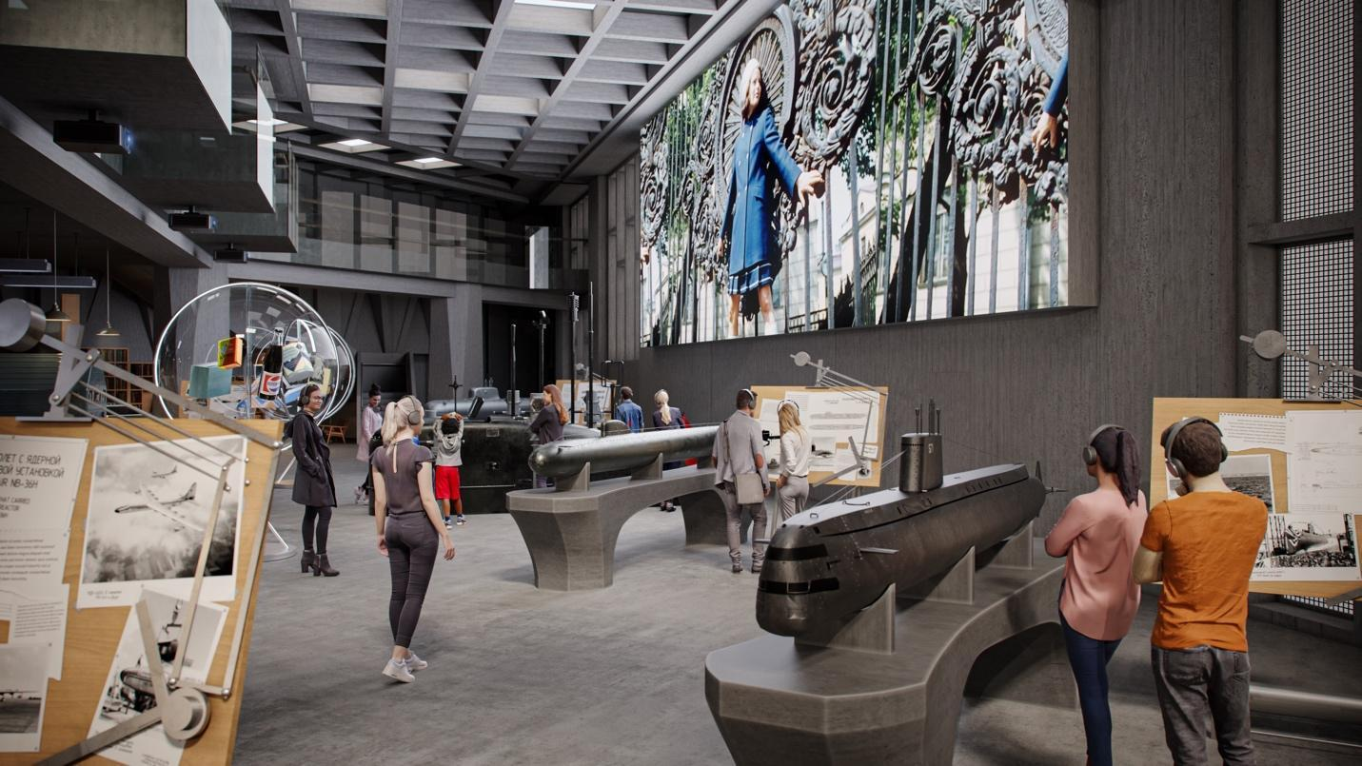

Read the information presented in the exhibition area “2.3. Submarines” and do the tasks.

**5.** **Fill in the missing names of nuclear submarines in the text.**

In 1958, the nuclear submarine 1) ____________ successfully completed the first passage under the ice of the North Pole in human history.

In 1962, for the first time in the history of the Russian fleet, the nuclear submarine 2) ________________________ surfaced in the North Pole area. The submariners came to the surface and even played football on the ice.

***Answer: _______________***

The “Nautilus” submarine is another project of the nuclear age. Externally, the Nautilus is almost no different from boats using conventional fuel, even retaining its narrow bow, which ensures good speed when the boat is on the surface. This technical feature is rather a tribute to tradition, because theoretically, a nuclear-powered boat does not need to surface for recharging — its engine can run for months without interruption.

**6.** **The name of the submarine “Nautilus” is taken from the novel __________________________ .**

a) The Mystery of Two Oceans;

b) Moonzund;

c) Secret Fairway;

d) 20 000 Leagues under the Sea.

***Answer: ______***

**7. The author of the novel is ....**

a) Jules Verne;

b) Valentin Pikul;

c) Grigory Adamov;

d) Ray Bradbury.

***Answer: _____***

**8. Today, the “Nautilus” submarine...**

a) sails in the seas and oceans;

b) is a museum;

c) has been dismantled;

d) has been modernized.

***Answer:______***

**Section 2.8. The Spirit of Discovery**

**Audio track 3. “Achievements”. Sport**

The Soviet leadership understood that intensive construction and taming the forces of nature were impossible without good health and high morale. In the Soviet Union, mass sport was developed to form citizens. Physical education lessons were held in schools, and after classes children attended specialized sports clubs.

Since the early 1950s, the Soviet athletes won hundreds of medals at the Olympic Games. The country hosted the largest world and continental championships. The brightest of them was the 1980 Summer Olympics, which were held in six cities of the Soviet Union. Children's sports clubs were opened all over the country to raise new champions.

**9. Which of the emblems was chosen for the 1980 Summer Olympics in the Soviet Union?**

|  |  |  |  |
| --- | --- | --- | --- |
| **1.** |  | **2.** |  |
| **3.** |  | **4.** |  |
| **5.** |  | **6.** |  |

***Answer: _____***

**The internal design of the nuclear submarine**

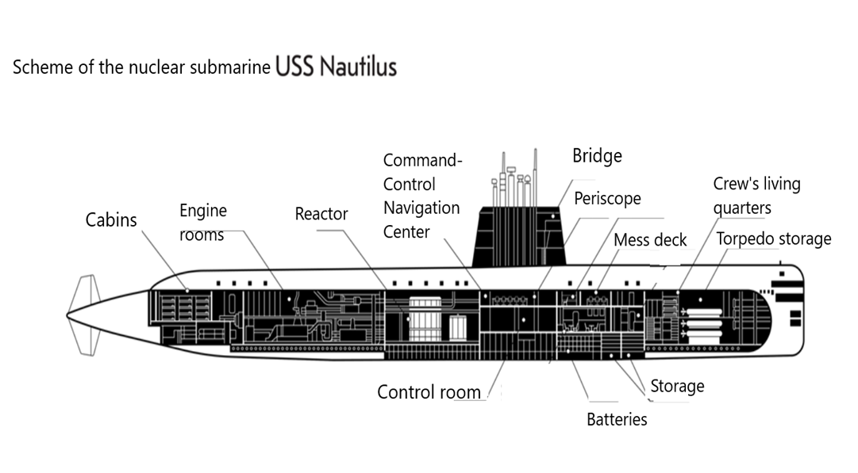

**10.** The interior of the nuclear submarine is divided into several parts within the three main compartments: torpedo room, living quarters and central post.

**Match the objects that can be found in different parts of the nuclear submarine (from 1 to 5) with their descriptions (from A to E)**.

1. Commander’s cabin

2. Mess deck

3. Folding bunks for submariners of the first compartment

4. Сontrol room for horizontal and vertical rudders

5. Torpedo fire control device

|  |  |
| --- | --- |
| **A** | Here sailors control the course of the submarine. On the left, they change the position of the vertical rudder, which allows the ship to turn. And at the combat post on the right, sailors control horizontal rudders to maneuver in depth. |
| **B** | When the submarine is at sea, part of the crew rests in the first compartment. For this purpose, right next to the torpedoes, folding bunks, water supply devices and a toilet are equipped for them. |
| **C** | The ship's commander is the only crew member of the K-3 nuclear submarine living in a personal cabin. All 104 crew members report to him: officers, petty officers and seamen. Along with the bunk, desk and wardrobe, the commander’s cabin contains safes with officers’ personal weapons and fuses for torpedoes not yet loaded into torpedo tubes. |
| **D** | Torpedo tubes are designed to store combat shells on board and launch them to hit a target. Eight such devices are located in the bow of the K-3 nuclear submarine. |
| **E** | Here, officers eat, relax and hold meetings, and sometimes watch movies and organize other entertainment events. During meetings and meals, the commander and his senior assistants sit at a small table. |

***Answers:***

___________________

___________________

___________________

___________________

___________________

**The First Tokamak**

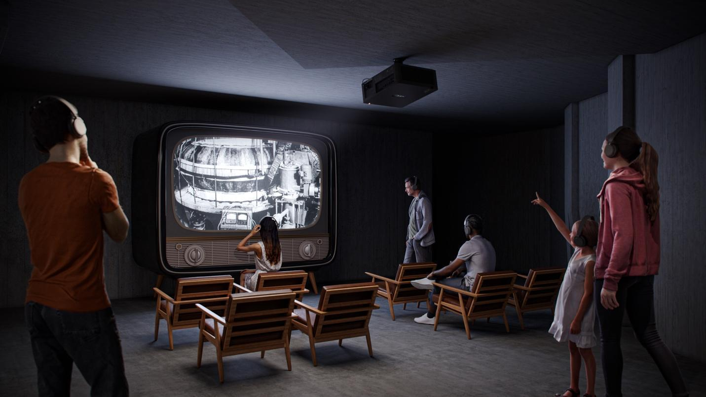

**11.** **Read the text and fill in the gaps with the missing words from the box.**

|  |
| --- |
| ***inductor, vacuum, device, plasma, thermonuclear, conducting, magnetic*** |

April 25, 1956. Kurchatov speaks in England, at the Atomic Institute in Harwell, in front of a packed hall. His speech amazes the audience. It turns out that the USSR has been ______1.________classified experiments with controlled _______2.______ fusion for two years. Now Kurchatov is ready to tell the whole world about them. During the experiments, the Soviet scientists manage to heat _____3._____ from deuterium atoms to a million degrees. The key tool is a new _____4.______ called a tokamak.

The device consists of a donut-shaped _____5._____ chamber, ____6._____ coils, an _____7._______ and a solenoid. The leading Soviet scientists developed the design; one of them was Lev Artsimovich, а physicist.

***Answer:***

1.__________

2. __________

3. __________

4. __________

5. __________

6. __________

7. __________

**Section 2.2. Atomic Hopes**

**The bridge of the icebreaker “Lenin”. Interactive program (map)**

**“Northern Sea Route”**

**12.** Read the texts about different types of ships. Look at the map with the dotted line of the Northern Sea Route and the navigation of ships along it. Tap on the screen, select a language and get access to the main content. The icons of moving ships are marked with Roman numerals in the chronological order. The icons of the ships are linked to the timeline under the map.

**Find the following types of ships according to their descriptions.**

*Steamboat; Koch; Sailing vessel, boat, packet boat and dubel-boat*

1. This is a vessel of the Pomors living on the coast of the White Sea since ancient times. Local sailors have been moving on such ships along the Eurasian coast since the XVI century. The ship hull is designed to withstand ice compression, and is excellent for Arctic shipping. ***Answer: ____________***

2. This Western-type vessel appeared in Russia in the second half of the XVII century. Strong vessels capable of withstanding long voyages started to sail in the northern waters at the beginning of the XVIII century. They were used in Arctic research expeditions and transportation. ***Answer:* _____________________**

3. This vessel proves its superiority over sailing ships at the beginning of the XIX century. It does not depend on rowers and wind. Thanks to a new source of energy, it can make long-distance crossings. In the second half of the XIX century, it explores the Arctic, helps to discover new islands and provides the passability of the Northern Sea Route. ***Answer:* __________**

**14. Tap on the screen, select a language and get access to the main content. Match the names of the following nuclear icebreakers with the corresponding information.**

**1.** “Sibir”, **2.** “Lenin”, **3.** “Arktika”.

**A.** It started regular winter-spring icebreaking to the Yamal Peninsula in 1976.

**B.** This is the first ship in the world to reach the North Pole in a surface voyage on August 17, 1977.

**С.** From January to December 1978, it carried outyear-round navigation on the Murmansk – Dudinka line for the first time.

***Answers:* __________________________________________________________________**